Superstore Sales and Profitability Analysis
Tools: Python, SQL, Excel, Power BI

- Project Overview
This project analyzes the retail sales and profitability data from Superstore dataset to answer the business question: “Why do some products and regions generate more sales but less profit?” On the surface, the business looks good with millions in sales every year. But when we look closer, we see that revenue and profit do not always move together, some products are selling the most but actually generate the least profit
The analysis follows a full analytics workflow: inspecting and cleaning the raw dataset in Python, exploring it with SQL, visualizing findings in Excel, and building a dashboard in Power BI
Workflow
1. Inspect raw dataset (column meanings, data types, missing values, duplicates, date range)
2. Define the business problem
3. Clean and prepare the data in Python (pandas)
4. Load into SQL database and run business analysis
5. Build pivot tables and charts in Excel
6. Build an interactive dashboard in Power BI
7. Summarize the business insights

- Dataset
2.1 About the Dataset
The dataset is Superstore retail dataset from Kaggle, comprising order sales transactions from a US retailer. Here is the summary of dataset included:
- Rows: 9,994
- Columns: 21 (order/ship dates, customer, geography, product, sales, quantity, profit, discount)
- Categories: Furniture, Office Supplies, Technology
- Regions: Central, East, South, West
- Segments: Consumer, Corporate, Home Office
- Missing data: none across all 21 columns
2.2 Data Preprocessing
- Data Loading: Imported the dataset using Python pandas
- Initial Exploration: Used df.info() and df.dtypes to check the structure and data types
- Order Date and Ship Date were of object type, so we converted them into the proper datatime format
- Used df.describe() to see the summary statistics

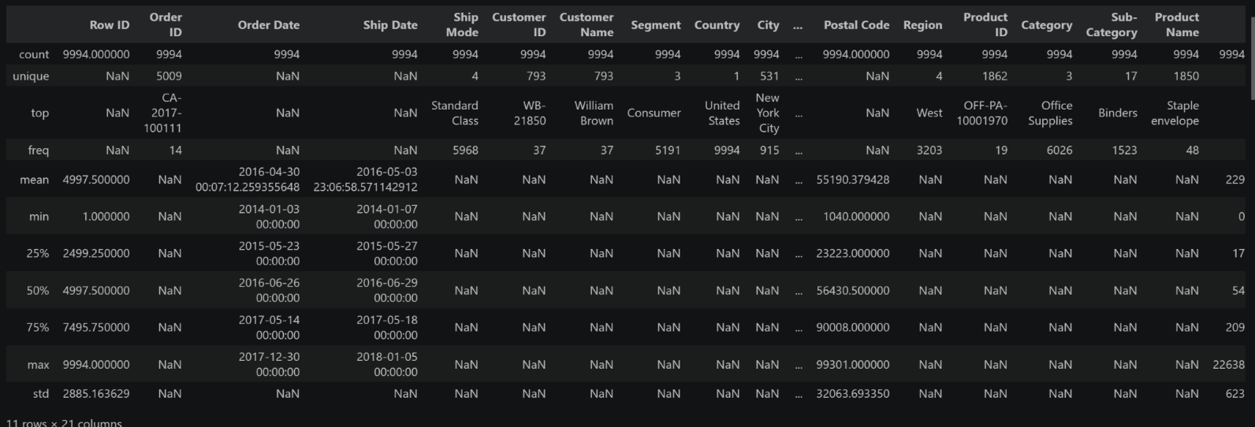

Figure 1: Dataset summary statistics

- Missing Data Handling: Checked for null values, verified zero duplicated rows and no invalid values (e.g., no negative values in sales and quantity, discount within 0-80%)
- Column Standardization: Renamed columns to snake_case for readability and documentation
- Confirmed no logical errors such as ship date occurring before the order date
- Database Integration: Connected Python script to SQLite and loaded the cleaned data into the database for SQL analysis
- Exploratory Data Analysis
In the summary statistics, the mean sale amount, $229.86 was far higher than the median $54.49, indicating that a few orders are large and pulling the average up. This means the median, not the mean, better represents a typical transaction.
A key early finding: 1,871 of 9,994 order items resulted in a loss, setting up the central analysis for this
project - identifying the factors that distinguish profitable transactions from unprofitable ones
- SQL Analysis
  - Discount Level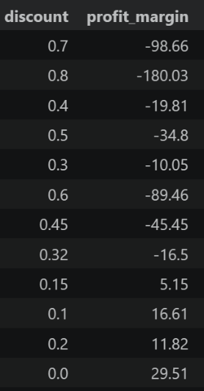

Figure 2: Discount impact on profit margin
Figure 2 shows at discount 0%, or discount below 20% then it stays profitable. But once discount is over 30%, it turns into a negative profit, resulting in a loss
4.2 Product categories’ total sales, total profit and margin
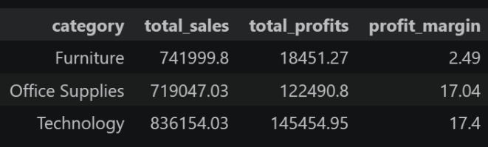
Figure 3: Sales and profit by category
Technology generated the highest total sale $836,154 and highest total profit $145,454. However, the Furniture’s sales are roughly comparable to Office Supplies' sales, but the Office Supplies generated significant higher profit. This represents a significant profitability gap
4.3 Sub-categories in Furniture driving a loss
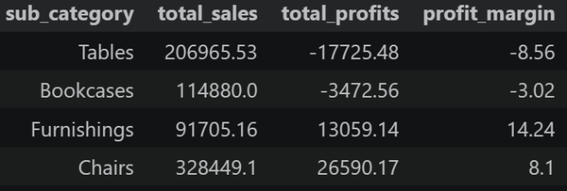
Figure 4: Sub-categories in Furniture
Despite generating nearly as much revenue as Office Supplies, Furniture’s profit is a fraction of the other two categories. Drilling into sub-categories showed the cause: Tables (-$17,725.48, -8.56% margin) and Bookcases (-$3,472.56, -3.02% margin) are the only two sub-categories operating a loss
4.4 Region - what region generates best margin
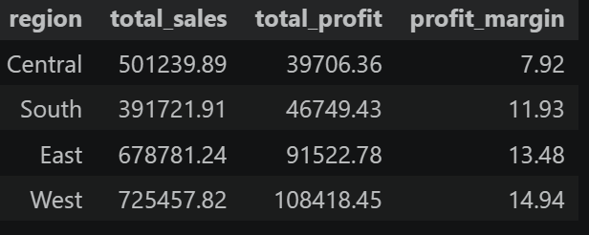
Figure 5: Sales and profit by region
Central has high sales but low profit with lowest margin of any region. Breaking Central down by state showed this was not a region-wide issue:
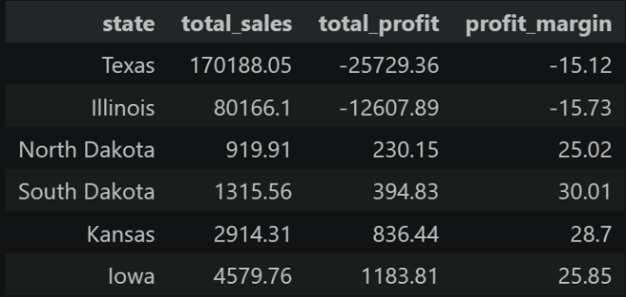
Figure 5.1: Sales and profit in Central’s state

Texas (-$25,729 loss, -15.12% margin) and Illinois (-$12,607 loss, -15.73% margin) were the only two states in Central operating at a loss, every other Central state posted 25-30% margin
4.5 Yearly Trend
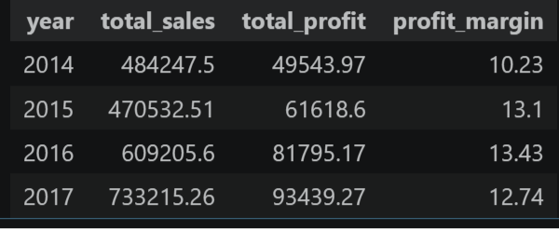Figure 6: Sales and profit changed by year
Sales and profit both grew every year, the most recent period recording the highest sales and profit was 2017. However, it was not the highest profit margin, its margin declined from 13.43% in 2016 to 12.74% in 2017. This suggests that the additional sales in 2017 were slightly less profitable
4.6 Top 5 products by sales/profit
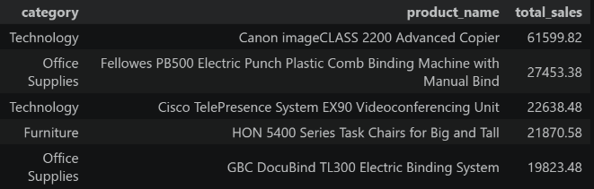Figure 7.1: Top 5 products by sales
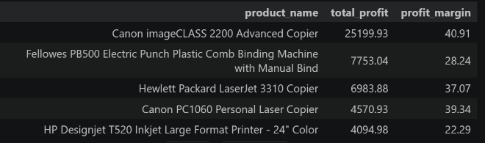
Figure 7.2: Top 5 products by profit
We can see Canon imageClass Copier led both sales and profit. Some products sold really well, but that strong selling didn’t turn into strong profit (e.g Cisco TelePresence appears in the top sales list but not in the profit list)
- Visualization & Dashboard
  - Excel
A static, one-page built dashboard with pivot tables and calculated fields, featuring five charts (bar and line) covering Category, Region, Discount, Segment, and Time. Each paired with a summary strip showing Total Sales, Total Profit, Margin, and Total Orders
  - Power BI
An interactive dashboard build on DAX measures, featuring KPI cards, slicers (Category, Region, Year) and visuals including Top 5 Products by Sales and by Profit, Sales and Profit by Sub-category, Discount Impact on Profit, Sales and Profit by Region, and Sales and Profit trend line by year which allow viewers to filter and drill into any finding directly
- Conclusion
Superstore generated $2,297,200.86 in sales, $286,397.02 in profit (12.47% overall margin), across 5,009 total orders. But this headline number hides an underlying pattern: profitability is not driven by which products sell or where they are sold, but by how heavily they are discounted

Reference
BINI_B1997. “Superstore.” Kaggledatasets, 22 Oct. 2025, https://www.kaggle.com/datasets/binib1997/superstore. Accessed 4 Sept. 2026.

